Template D: short texts for newsletters, websites and social media
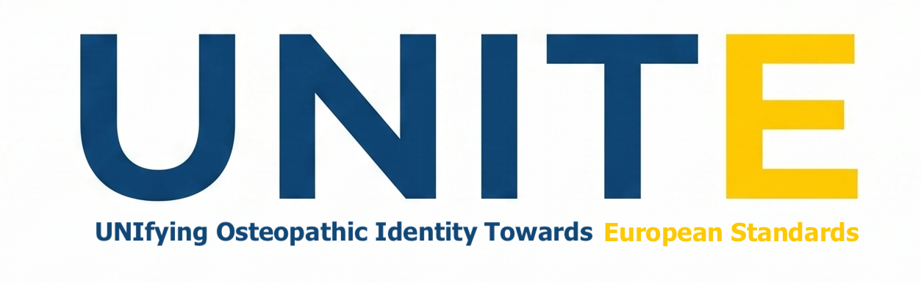
Before 9 November 2026, use the texts as they are. After that date, replace “ideally by 9 November 2026” with “now”.

Newsletter or website (about 80 words)
What makes an osteopath an osteopath? The international UNITE study is asking osteopaths, educators, researchers, students, patients and carers, association representatives, regulators and other healthcare professionals who work with osteopaths. The results will inform the revision of the European standard for osteopathic healthcare provision (EN 16686). The study is available in eight languages and starts with a short online form. Please register your interest, ideally by 9 November 2026: https://redcap.hes-so.ch/surveys/?s=M83HLKXTN38E78HA

Social media, short (about 40 words)
What makes an osteopath an osteopath? Take part in UNITE, the international study that will inform the European standard for osteopathy. Open to osteopaths, educators, students, patients and more. Eight languages. Register, ideally by 9 November 2026: https://redcap.hes-so.ch/surveys/?s=M83HLKXTN38E78HA
#UNITEstudy #Osteopathy #OsteopathyEurope

Social media, long (about 100 words)
Who should help shape the European standard for osteopathy? You.
UNITE (UNIfying Osteopathic Identity Towards European Standards) is an international study on what defines osteopathy and what it means to be an osteopath. It is run by the Centre for Osteopathic Research and Leadership at Health Sciences University (UK), with Osteopathy Europe.
We want to hear from osteopaths, educators, students, patients and carers, and more. The form is short and is available in eight languages. It stays open until Stage 2 starts in early 2027.
Register, ideally by 9 November 2026: https://redcap.hes-so.ch/surveys/?s=M83HLKXTN38E78HA
More information: https://osteopathyeurope.org/unite/
#UNITEstudy #Osteopathy #OsteopathyEurope #EuropeanStandards

