Template B: note to schools and universities, with a message to forward
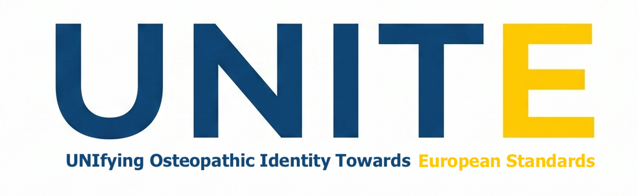
Subject: UNITE study: invitation for your teaching staff, researchers and students
Dear [name],
[Association name] is supporting UNITE, an international study on osteopathic professional identity that will inform the revision of the European standard for osteopathic healthcare provision (EN 16686). Educators, researchers and students are three of the groups the study most needs to hear from.
Could you forward the message below to your teaching staff, clinic tutors, researchers and students? Please send it to everyone, in all years of study, and make clear to students that taking part is their choice and has no link with their studies or assessment.
Thank you for your help.
[Name, role, association]

Message to forward
Dear colleagues and students,
You are invited to take part in UNITE (UNIfying Osteopathic Identity Towards European Standards), an international study on what defines osteopathy and what it means to be an osteopath. The results will inform the revision of the European standard for osteopathic healthcare provision (EN 16686). The study is run by the Centre for Osteopathic Research and Leadership at Health Sciences University (UK), with Osteopathy Europe.
Who can take part?
- Educators and researchers: you currently teach, supervise or assess osteopathic students, or you do research on osteopathy as part of your work, in a recognised osteopathic programme, a university or a research institution.
- Students: you are enrolled in a programme that leads to qualification as an osteopath. Students in all years are welcome.
- Everyone: you are 18 or over and can read and write in Dutch, English, French, German, Italian, Portuguese, Spanish or Russian.
What does it involve?
- Now: complete the short expression of interest form: https://redcap.hes-so.ch/surveys/?s=M83HLKXTN38E78HA. Places in Stage 1 are selected from the registrations received by 9 November 2026. The form stays open after that date, and people who register later are invited to Stage 2.
- From 10 November 2026 (Stage 1): a small number of people, selected to balance groups, regions and gender, answer open questions in writing.
- Early 2027 (Stage 2): everyone who is eligible is invited to rate statements in online questionnaires.
Taking part is voluntary. The form explains the study and how your answers will be used before you decide.
Questions about the study: Louisa Henson, Louisa.Henson@hsu.ac.uk. More information: https://osteopathyeurope.org/unite/

